PRAGATI ENGINEERING COLLEGE (A)
Surampalem
DEPARTMENT OF COMPUTER SCIENCE AND ENGINEERING
SNAKE GAME
SUBMITTED BY:
G. Sri Siri (Team Lead) – 25A31A0574
M.Snehanjali - 25A31A0584
N. Durga Prasad - 25A31A05AS
M.Ganesh - 25A31A05AR

Under the Guidance of:

Mrs. T.N.V. Durga
CSE Department

1. Project Description
The Snake game is a classic arcade-style application where the player navigates a growing snake across a grid to consume food. The primary goal is to achieve the highest score possible by eating food items, which causes the snake to grow in length and increases the difficulty of maneuvering within the bounded play area.

Core Objectives
Movement Control: Implement real-time response to directional inputs (Up, Down, Left, Right) to guide the snake.Growth Mechanics: Each time the snake "eats" a food pellet, its body length increases by one unit, and the score increments.

Collision Logic: The game ends immediately if the snake’s head touches the screen boundaries or intersects with its own body.Technical ImplementationThe project is built around a game loop that constantly updates the snake's position and checks for game-over conditions. Data structures like arrays or deques are used to track the coordinates of the snake's body segments. To ensure fairness, food is spawned using a random coordinate generator that avoids placing items directly on the snake's current path.Development ToolsCommonly developed using c++ for web-based play, this project highlights essential programming concepts such as event handling, coordinate geometry, and basic state management.

2. System Architecture
The system architecture for a snake game in C++ follows a modular, Object - Oriented (OO) approach designed around a central game loop. It typically separates core gameplay logic from rendering and input handling to ensure the code is maintainable and easily extensible (e.g., swapping a console display for a graphics library like SFML).

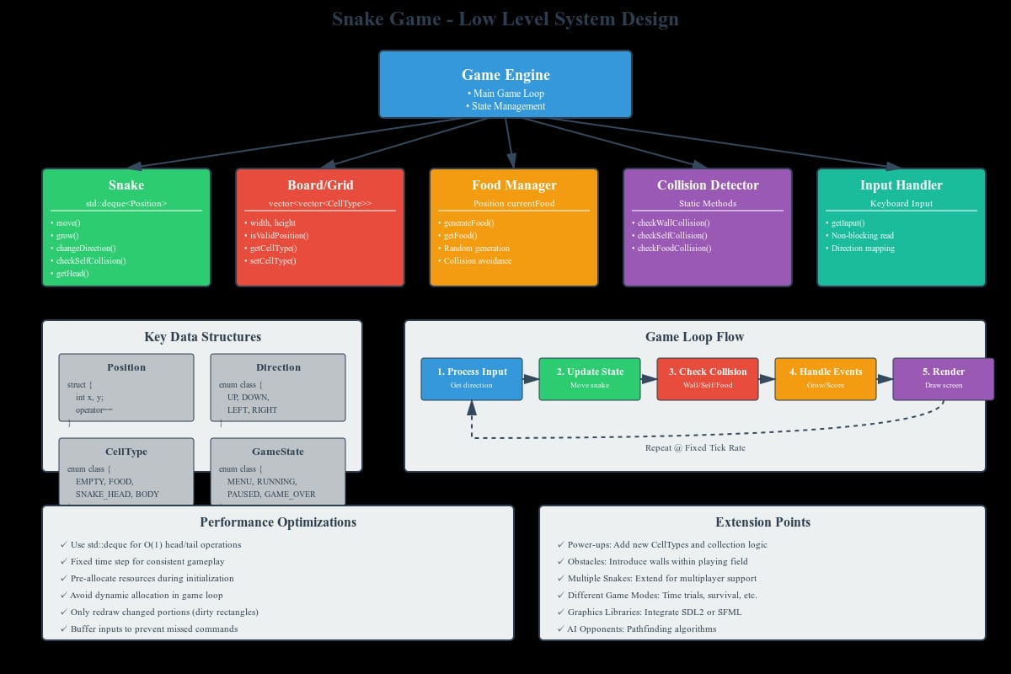
ALGORITHM
Step 1:
Start the game and initialize the snake at the starting position on the game screen.
Step 2:
Generate food at a random position on the screen.
Step 3:
Accept user input to move the snake in a direction (Up, Down, Left, or Right).
Step 4:
Move the snake in the selected direction and check if the snake eats the food.
If the snake eats the food, increase the snake length and generate new food.
Step 5:
Check if the snake collides with the wall or its own body.
If collision occurs, end the game.
Step 6:
Repeat Steps 3 to 5 until the game ends, then display the final score and stop the game.

